DLD LAB

Assignment # 3

Submitted By: Areeba Farooq

Submitted to: Mam Warda

Registration # 200901058

Section:A



**Date: 9th Feb, 2021**

**OBJECTIVES:**

• We got to learn how to utilize software

• To learn how to create gates with distinctive ICs

• To learn how to create truth table for distinctive gates

• Learn how to join connections

• Learn Boolean expression

• Learn to solve distinctive gates equations

• Simplify Boolean expression at that point implement

• Make distinctive connections

• Use of 4 inputs gate and its connections

**PROCEDURE:**

• First we ought to make truth tables

• Make Circuit diagrams for all gates which are required

• Make circuit diagrams

• Make gates by utilizing 4 inputs

• Join distinctive connections

• Simplify the Boolean expression at that point implement

• Implement Boolean expression on distinctive logic diagrams

• Verify truth tables

• Check logic gates by exchanging on or off the gates

**TASK 01**

* 1. **Implement the following equations and verify your results:**

1. **AB’+A’B**

**TRUTH TABLE**

|  |  |  |  |  |  |  |
| --- | --- | --- | --- | --- | --- | --- |
| A | B | A’ | B’ | AB’ | A’B | AB’+A’B |
| 0 | 0 | 1 | 1 | 0 | 0 | 0 |
| 0 | 1 | 1 | 0 | 0 | 1 | 1 |
| 1 | 0 | 0 | 1 | 1 | 0 | 1 |
| 1 | 1 | 0 | 0 | 0 | 0 | 0 |

**LOGIC DIAGRAM**

|  |
| --- |
| A A’ A’B  B B’ AB’ |

**CIRCUIT DIAGRAM**

  
  


**b. A’B+A’C+BC**

**TRUTH TABLE**

|  |  |  |  |  |  |  |  |  |
| --- | --- | --- | --- | --- | --- | --- | --- | --- |
| A | B | C | A’ | A’B | A’C | BC | A’B+A’C | A’B+A’C+BC |
| 0 | 0 | 0 | 1 | 0 | 0 | 0 | 0 | 0 |
| 0 | 0 | 1 | 1 | 0 | 1 | 0 | 1 | 1 |
| 0 | 1 | 0 | 1 | 1 | 0 | 0 | 1 | 1 |
| 0 | 1 | 1 | 1 | 1 | 1 | 1 | 1 | 1 |
| 1 | 0 | 0 | 0 | 0 | 0 | 0 | 0 | 0 |
| 1 | 0 | 1 | 0 | 0 | 0 | 0 | 0 | 0 |
| 1 | 1 | 0 | 0 | 0 | 0 | 0 | 0 | 0 |
| 1 | 1 | 1 | 0 | 0 | 0 | 1 | 0 | 1 |

**LOGIC DIAGRAM**

|  |
| --- |
|  |

**CIRCUIT DIAGRAM**

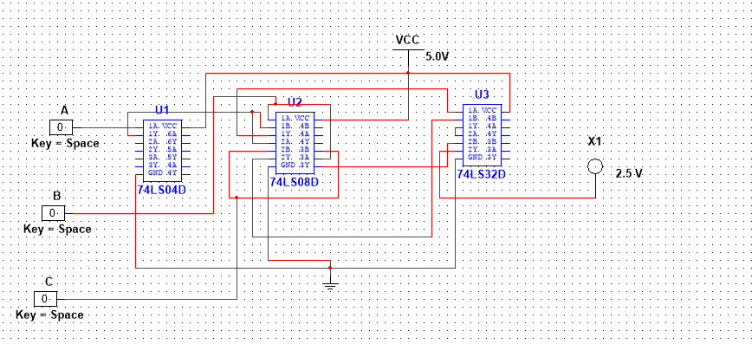  
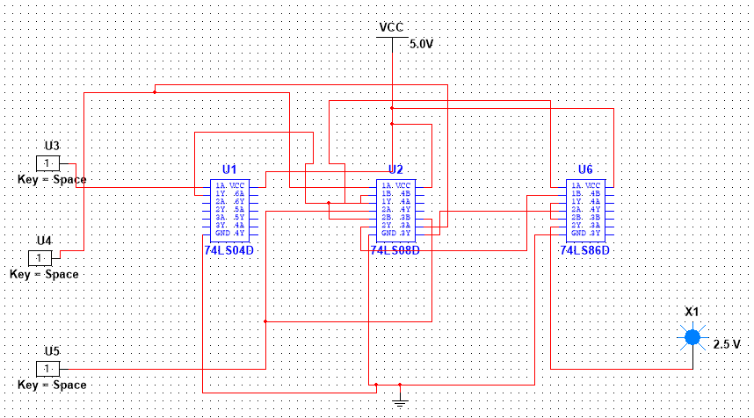

1. **DABC+D’A+A’BC**

**TRUTH TABLE**

|  |  |  |  |  |  |  |  |  |  |  |  |  |
| --- | --- | --- | --- | --- | --- | --- | --- | --- | --- | --- | --- | --- |
| A | B | C | D | A’ | D’ | DA | BC | D’A | DABC | A’BC | DABC+D’A | A’BC+DABC+D’A |
| 0 | 0 | 0 | 0 | 1 | 1 | 0 | 0 | 0 | 0 | 0 | 0 | 0 |
| 0 | 0 | 0 | 1 | 1 | 0 | 0 | 0 | 0 | 0 | 0 | 0 | 0 |
| 0 | 0 | 1 | 0 | 1 | 1 | 0 | 0 | 0 | 0 | 0 | 0 | 0 |
| 0 | 0 | 1 | 1 | 1 | 0 | 0 | 0 | 0 | 0 | 0 | 0 | 0 |
| 0 | 1 | 0 | 0 | 1 | 1 | 0 | 0 | 0 | 0 | 0 | 0 | 0 |
| 0 | 1 | 0 | 1 | 1 | 0 | 0 | 0 | 0 | 0 | 0 | 0 | 0 |
| 0 | 1 | 1 | 0 | 1 | 1 | 0 | 1 | 0 | 0 | 1 | 0 | 1 |
| 0 | 1 | 1 | 1 | 1 | 0 | 0 | 1 | 0 | 0 | 1 | 0 | 1 |
| 1 | 0 | 0 | 0 | 0 | 1 | 0 | 0 | 1 | 0 | 0 | 1 | 1 |
| 1 | 0 | 0 | 1 | 0 | 0 | 1 | 0 | 0 | 0 | 0 | 0 | 0 |
| 1 | 0 | 1 | 0 | 0 | 1 | 0 | 0 | 1 | 0 | 0 | 1 | 1 |
| 1 | 0 | 1 | 1 | 0 | 0 | 1 | 0 | 0 | 0 | 0 | 0 | 0 |
| 1 | 1 | 0 | 0 | 0 | 1 | 0 | 0 | 1 | 0 | 0 | 1 | 1 |
| 1 | 1 | 0 | 1 | 0 | 0 | 1 | 0 | 0 | 0 | 0 | 0 | 0 |
| 1 | 1 | 1 | 0 | 0 | 1 | 0 | 1 | 1 | 0 | 0 | 1 | 1 |
| 1 | 1 | 1 | 1 | 0 | 0 | 1 | 1 | 0 | 1 | 0 | 1 | 1 |

**LOGIC DIAGRAM**

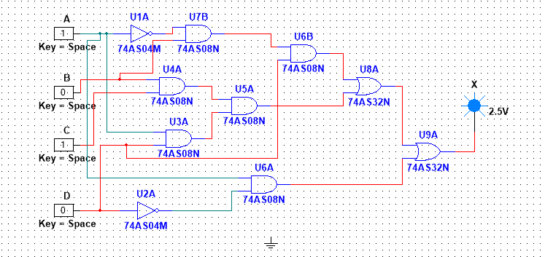

**CIRCUIT DIAGRAM**





**TASK#02**

1. **Implement the following expressions after simplification with minimum number of gates.**

**a.X = ((A.B’). (A+C))’ + A’. B. (A + B’ + C’)’**

**SIMPLIFICTION**

|  |
| --- |
| **=**((A.B).A+C)’+A’B(A’.B.C)  =(A.B)’+(A+C)’+(A’.B).(A’.B.C)  =A’+B+A’C’+A’A’BBC  =A’+B+A’C+A’BC  =A’(1+C’+BC)+B  =A’(1+BC)+B  =A’(1)+B  X=A’+B |

**TRUTH TABLE**

|  |  |  |  |
| --- | --- | --- | --- |
| A | B | A’ | X=A’+B |
| 0 | 1 | 1 | 1 |
| 0 | 0 | 1 | 1 |
| 1 | 1 | 0 | 1 |
| 1 | 0 | 0 | 0 |

**LOGIC DIAGRAM**





**CIRCUIT DIAGRAM**





1. **Y = (X + A) (X’ + A) (A + C) (A + D) X**

**SIMPLIFICATION**

|  |
| --- |
| =(A+(X.X’))((A+C)(A+D))X  =(A+0)((A+(C.D))X  =A(A+(C.D))X  =A.X |

**TRUTH TABLE**

|  |  |  |
| --- | --- | --- |
| A | X | Y=A.X |
| 0 | 0 | 0 |
| 0 | 1 | 0 |
| 1 | 0 | 0 |
| 1 | 1 | 1 |

**LOGIC DIAGRAM**





**CIRCUIT DIAGRAM**





**C.Z =(A + B) (A + B’)**

**SIMPLIFICATION**

|  |
| --- |
| = (A + B) (A + B**’**)  =A+(B.B’)  =A.0  =A |

**TRUTH TABLE**

|  |  |
| --- | --- |
| A | Z |
| 0 | 0 |
| 1 | 1 |

**LOGIC DIAGRAM**

Same as a circuit diagram it has one connection

**CIRCUIT DIAGRAM**





**CONCLUSION**

• We have studied about distinctive logic and circuit gates

• We have learn that how to form truth tables for distinctive gates

• We have learn that how to create distinctive connections with 2, 3 and 4 input gates

• We have learn how to solve or simplify Boolean expression

• We have learned about on and off to check or confirm truth tables